# Quinte Financial Technologies | FinTech Solutions

**Assignment on**

**HEALTH SAVINGS ACCOUNT AND PERSONAL LOANS**

**Under Supervision of:**

**Mr. Mohammad Mozammil**

**Submitted On:**

**26th June, 2024**

**Submitted By:**

**Archita Gupta**

Table of Contents

Health Savings Accounts 3

Personal Loans 6

# Health Savings Accounts

A health savings account (HSA) is a tax-advantaged medical savings account available to taxpayers in the United States who are enrolled in a High-Deductible Health Plan (HDHP).  It features what’s called the “triple tax advantage”: tax-deductible contributions and tax-free growth and withdrawals.

A HDHP is a health insurance plan with lower premiums and higher deductibles than a traditional health plan. It is intended to incentivize consumer-driven healthcare.

Contributions are made into the account by the individual or their employer and are limited to a maximum amount each year. These contributions are invested over time and can be used to pay for qualified medical expenses, such as medical, dental, and vision care and prescription drugs. The funds contributed to a HSA account are not subject to federal income tax at the time of deposit and also funds roll over and accumulate year to year if they are not spent.

HSAs were established as part of the Medicare Prescription Drug, Improvement, and Modernization Act, which included the enactment of Internal Revenue Code section 223, effective for tax years beginning after December 31, 2003, signed into law by President George W. Bush on December 8, 2003. They were developed to replace the medical savings account system.

* **Eligibility**:
* Must be enrolled in a High Deductible Health Plan (HDHP).
* Cannot be enrolled in Medicare.
* Cannot be claimed as a dependent on someone else’s tax return.
* Cannot have any other health coverage, with some exceptions like dental, vision, disability, and long-term care insurance.

|  |  |  |  |  |  |  |
| --- | --- | --- | --- | --- | --- | --- |
|  | **Contribution Limits** | | **Minimum Deductible** | | **Out of Pocket Maximum** | |
|  | Individual | Family | Individual | Family | Individual | Family |
| 2023 | 3850 | 7750 | 1500 | 3000 | 7500 | 15000 |
| 2024 | 4150 | 8300 | 1600 | 3200 | 8050 | 16100 |

* **Contribution Limits (2024)**:
* Additional catch-up contribution for those aged 55 and older: $1,000.

The annual limits on contributions apply to the total amounts contributed by both the employer and the employee. Contributions can only be made in cash, while employer-sponsored plans can be funded by the employee and their employer.

* **Minimum Deductible (2024):** The minimum amount an HDHP must require before insurance coverage kicks in.HDHPs have higher annual deductibles (the plan pays nothing until you reach these amounts in out-of-pocket expenses) but lower premiums than other health plans.
* **Out of Pocket Maximum (2024):** An out-of-pocket maximum is the most you have to pay per year for covered healthcare services. An out-of-pocket maximum helps you to control the cost of your healthcare because you know the maximum you will ever have to pay in a year.

**Usage:**

1. Medical expenses:

* Pay for current medical expenses
* Save for future healthcare costs

1. Retirement planning:

* Use as a supplemental retirement account
* Pay for healthcare costs in retirement

1. Investment strategy:

* Short-term: Keep funds liquid for immediate medical needs
* Long-term: Invest for potential growth

**Advantages and Disadvantages of HSA:**

|  |  |
| --- | --- |
| **Pros** | **Cons** |
| * Contribution tax advantages * Distribution tax advantages * Investment options | * Deductible requirements * Requires extra cash * Filing requirements |

**HSA vs. Flexible Spending Account:**

The HSA is often compared with the Flexible Spending Account (FSA). While both accounts can be used for medical expenses, some key differences exist between them are:

* FSAs are employer-sponsored plans.
* Only employed individuals can sign up for FSAs.
* Unused funds in the FSA during a given tax year can’t be rolled over and are forfeited once the year ends.
* Elected contribution amount for an FSA is fixed, unlike HSA contributions

The maximum contribution for an FSA for the 2024 tax year is $3,200.

**Recent Developments:**

1. **Growing Popularity**: According to Devenir Research, HSA assets reached $98.8 billion across 32.5 million accounts as of June 30, 2022, a year-over-year increase of 17%.
2. **Investment Options**: More HSA providers are offering investment options beyond low-yield savings accounts. Devenir reports that HSA investment assets reached $34.4 billion as of June 30, 2022, a 19% year-over-year increase.
3. **Tech Integration**: HSA providers are increasingly offering mobile apps and digital platforms for easier account management and spending.
4. **Expanded Use Cases**: The CARES Act of 2020 permanently expanded HSA-eligible expenses to include over-the-counter medications and menstrual care products.
5. **HSA as a Retirement Tool**: There's a growing trend of using HSAs as a complement to traditional retirement accounts, given their unique tax advantages.
6. **Legislative Proposals**: Various bills have been introduced in Congress to expand HSA eligibility and increase contribution limits, though none have become law as of 2024.
7. **Employer Strategies**: More employers are offering HSA-eligible health plans and contributing to employees' HSAs as a way to manage healthcare costs and enhance benefits packages.

**Best health savings accounts (HSAs):**

|  |  |  |  |  |  |
| --- | --- | --- | --- | --- | --- |
| **HSA** | **Best for** | **Cash APY\*** | **Minimum opening deposit** | **Minimum investment threshold** | **Monthly fees** |
| Fidelity Investments | Investors | 4.98% | None | None | Account fee: None; Investing fee: None |
| Bank of America | Traditional bank | 0.10% to 0.70% | None | $1,000 | Maintenance fee: $2.50; Investing fee: None |
| Lively | Transparency | 0.020% to 0.525% | None | None | Schwab HSBA investing fee: $24 per year or $3,000 minimum balance; HSA Guided Portfolio investing fee: 0.50% of invested assets |
| Optum Bank | Large accounts | N/A | None | $2,000 | Account fee: $3.75 per month, waived for balances over $5,000 |
| HealthEquity | Robo-advisors | N/A | None | $1,000 | Investing fee: 0.03% monthly fee of 0.03% of investment account balance, capped at $10; AutoPilot and GPS fees: 0.05% monthly fee of account balance, capped at $15 |

# Personal Loans

Personal loans are a type of installment loan that individuals can use for a variety of purposes, such as consolidating debt, financing home improvements, covering unexpected expenses, or funding large purchases.

Personal loans can be offered by banks, credit unions, or online lenders. It loan allows you to borrow a lump sum of money to pay for a variety of expenses and then repay those funds in regular payments, or installments, over time. For example, a personal loan can be used to cover:

* Moving expenses
* Debt consolidation
* Medical bills
* Wedding expenses
* Home renovations or repairs
* Funeral costs
* Vacation costs
* Unexpected expenses

Personal loans are different from other installment loans—such as student loans, car loans, and mortgage loans—that are used to fund specific expenses like education, vehicles, or homes.

**Key Features:**

1. **Loan Amount**: Personal loans typically range from a few hundred dollars to $100,000, depending on the lender and the borrower's creditworthiness.
2. **Term Length**: Repayment terms generally range from 1 to 7 years. Shorter terms usually mean higher monthly payments but lower total interest costs, while longer terms have lower monthly payments but higher total interest costs.
3. **Interest Rates**: Interest rates can be fixed or variable. Fixed rates remain constant over the life of the loan, while variable rates can change periodically based on market conditions.
   * Rates vary widely based on credit score, income, and other financial factors. As of 2023, average interest rates range from 6% to 36%.
4. **Credit Score Impact**: Lenders evaluate credit scores to determine eligibility and interest rates. Higher credit scores typically result in lower interest rates.
   * Applying for a personal loan can temporarily affect your credit score due to the hard inquiry made during the application process.
5. **Secured vs. Unsecured**:
   * **Unsecured Loans**: Do not require collateral. Approval is based on creditworthiness and financial history. These are more common for personal loans.
   * **Secured Loans**: Require collateral, such as a car, savings account, or other assets. These might have lower interest rates due to reduced risk for the lender.
6. **Fees**: Common fees include origination fees (1%-8% of the loan amount), late payment fees, and prepayment penalties (though many lenders do not charge prepayment fees).

**Considerations**

1. **Interest Costs**: Interest rates can be high, especially for borrowers with lower credit scores. It’s important to compare rates and terms from multiple lenders.
2. **Impact on Credit**: Missed or late payments can negatively affect your credit score. Responsible borrowing and timely payments are crucial.
3. **Fees and Penalties**: Be aware of any fees associated with the loan, including origination fees, late payment fees, and potential prepayment penalties.
4. **Repayment Obligation**: Borrowers must be confident in their ability to repay the loan, as defaulting can lead to serious financial and legal consequences.

**Market Trends (2024):**

* Americans owe $245 billion in personal loan debt as of the Q1, 2024, unchanged from the previous quarter but up $20 billion from a year earlier ($225 billion). That’s an 8.9% jump from the previous year.
* 23.5 million Americans have a personal loan as of Q1,2024, up from 22.4 million a year earlier ,i.e., 4.9% year-over-year increase.
* Personal loan debt makes up 1.4% of outstanding consumer debt. It accounts for 5.0% of non housing consumer debt.
* The delinquency rate (60 days or more past due) for personal loans is 3.75% as of 2024, decrease from 3.91% previous year.
* The average personal loan debt per borrower is $11,829 for 2024 and was $11,281 for 2023.
* Most borrowers (55.1%) take out a personal loan to consolidate debt or refinance credit cards. The next-closest reason is for everyday bills (7.0%).
* Credit score requirements: The average minimum credit score for personal loans decreased to 620 in 2024, down from 640 in 2023, as lenders expand their risk tolerance.

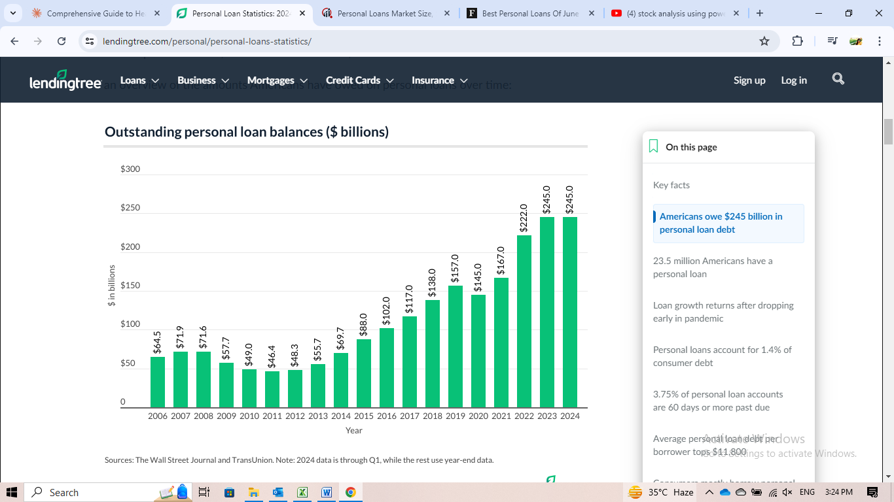

The chart depicts the outstanding personal loan balances in the United States from 2006 to 2024, measured in billions of dollars. Key analysis:

* Overall Growth Trend: There's a clear long-term upward trend in outstanding personal loan balances, especially from 2010 onwards.
* Pre-2010 Period: From 2006 to 2010, the balances remained relatively stable, fluctuating between $64.5 billion and $71.9 billion.
* Post-2010 Growth: Starting in 2011, there's a consistent and significant year-over-year increase, with a few exceptions.
* Rapid Expansion: The most dramatic growth occurred between 2015 and 2019, where balances more than doubled from $88.0 billion to $167.0 billion.
* COVID-19 Impact: There's a noticeable dip in 2020 to $145.0 billion, likely due to the economic effects of the COVID-19 pandemic.
* Post-Pandemic Recovery: From 2021 onwards, there's a sharp rebound and continued growth, reaching $245.0 billion by 2024 (Q1).

The personal loan market has grown by nearly 280% from its lowest point in 2010 ($49.0 billion) to its peak in 2023-2024 ($245.0 billion) suggesting a significant shift in consumer borrowing habits over the past decade, with personal loans becoming an increasingly popular financial product.

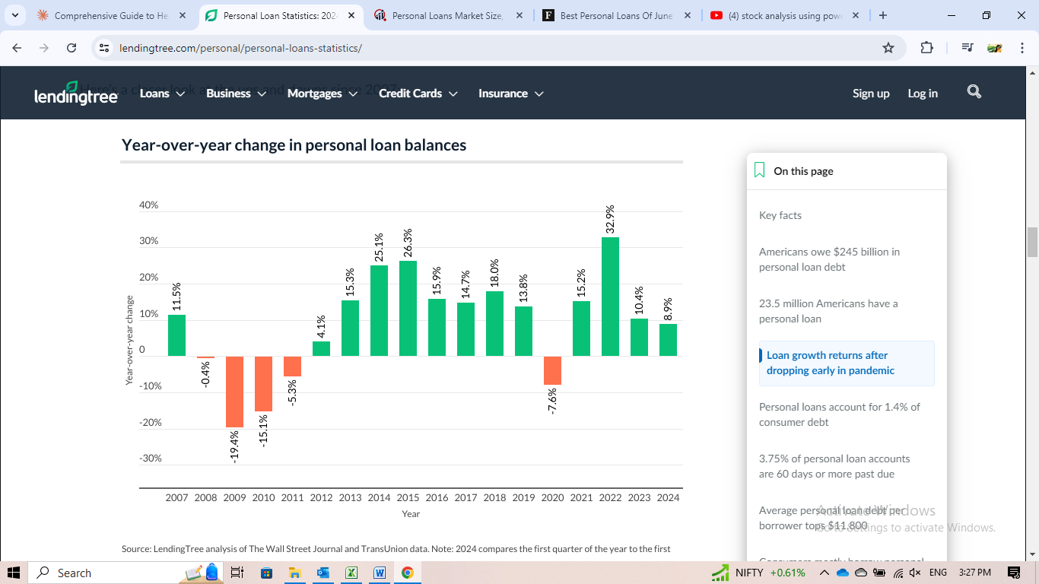

The chart illustrates the year-over-year percentage change in personal loan balances from 2007 to 2024. Key points:

1. Volatility in Early Years: From 2007 to 2011, there was significant volatility, with both positive and negative growth rates. 2009 saw the steepest decline at -19.4% likely due to tightened lending standards due to the financial crisis, reduced consumer confidence and spending, higher unemployment rates leading to decreased loan demand and banks focusing on reducing risk in their loan portfolios.
2. Recovery and Growth Phase: Starting in 2012, there's a consistent positive growth trend, indicating economic recovery post-recession, increased consumer confidence, loosening of credit standards as banks regained stability and rise of fintech companies making personal loans more accessible.
3. Peak Growth Period: The highest growth rates were observed between 2013 and 2015, with 2014 showing the maximum year-over-year increase of 25.3%. This can be attributed to pent-up demand for credit after years of deleveraging, emergence and rapid expansion of online lenders (e.g., LendingClub, Prosper), low interest rate environment making borrowing more attractive and increased marketing of personal loans as an alternative to credit cards.
4. Sustained Growth: From 2016 to 2018, growth remained strong, consistently above 10% year-over-year might be because of mainstream adoption of online lending platforms, expansion of personal loan offerings by traditional banks to compete with fintech, strong economy and low unemployment encouraging borrowing and usse of personal loans for debt consolidation becoming more popular.
5. Pre-Pandemic Slowdown: In 2019, there was a noticeable slowdown in growth to 13.8%, this slowdown likely reflected a combination of factors including market saturation in certain segments, growing concerns about overall consumer debt levels, and slight economic uncertainties that may have led both lenders and borrowers to exercise more caution.
6. Pandemic Impact: 2020 shows a significant negative growth of -7.6%. This decline was driven by widespread economic shutdowns and uncertainty, which led to tightened lending standards as financial institutions sought to mitigate risk. Consumer spending and borrowing decreased sharply during lockdowns, further reducing demand for personal loans.
7. Post-Pandemic Rebound: 2021 saw a dramatic rebound with the highest growth rate in the entire period at 32.7%, indicating pent-up demand or changed economic circumstances.
8. Recent Moderation: Growth rates in 2022 and 2023 have moderated to 10.4% and 8.9% respectively, suggesting a normalization of the personal loan market after the post-pandemic surge.

**Advantages and Disadvantages of Personal Loans:**

|  |  |
| --- | --- |
| **Pros** | **Cons** |
| * Fixed repayment terms * Potentially lower interest rates than credit cards * Can be used for various purposes * No collateral required for unsecured loans * Can help improve credit score if managed responsibly | * Higher interest rates than secured loans like mortgages * Potential for fees (origination, late payment, etc.) * Risk of debt cycle if not managed properly * May be difficult to qualify with poor credit * Fixed payments can be inflexible in financial hardship |

|  |  |  |  |  |
| --- | --- | --- | --- | --- |
| **Company** | **Best For** | **Minimum Credit Score** | **Current APR Range** | **Loan Amount** |
| SoFi | Good to Excellent Credit | 650 | 8.99% to 29.99% | $5,000 to $100,000 |
| Upgrade | Bad Credit | 580 | 8.49% to 35.99% | $1,000 to $50,000 |
| LightStream | Low Interest Rates | 660 | 6.99% to 25.49% | $5,000 to $100,000 |
| PenFed | Credit Union Financing | Does Not Disclose | 7.99% to 17.99% | $600 to $50,000 |
| Happy Money | Credit Card Debt Consolidation | 640 | 11.72% to 17.99% | $5,000 to $40,000 |
| U.S. Bank | Traditional Banking | Does Not Disclose | 8.74% to 24.99% | $1,000 to 50,000 to existing U.S. Bank customers (up to $25,000 for noncustomers) |

**Best Personal Loans of June 2024 by Forbes:**

Thank You